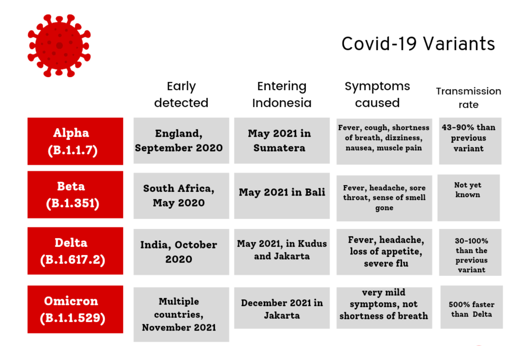

Among the four variants, delta is the most at risk, while Omicron is considered to be the least symptomatic of the four. In terms of transmission rate, Omicron variant is classified as the fastest variant, which is about 500% of the propagation of delta variant.

**Delta**

Delta variant is highly infectious, about twice as much as previous variants. However, the same precautions, such as avoiding crowded spaces, keeping a distance from others and wearing masks, still apply to the delta variant.

**Omicron**

Spread

The Omicron variant, like other variants, is comprised of a number of lineages and sublineages. The three most common lineages of Omicron currently are BA.1, BA.1.1 and BA.2. The Omicron variant spreads more easily than earlier variants of the virus that cause COVID-19, including the Delta variant. CDC expects that anyone with Omicron infection, regardless of vaccination status or whether or not they have symptoms, can spread the virus to others.

Symptoms

Persons infected with the Omicron variant can present with symptoms similar to previous variants. The presence and severity of symptoms can be affected by COVID-19 vaccination status, the presence of other health conditions, age, and history of prior infection.

Severe Illness

Omicron infection generally causes less severe disease than infection with prior variants. Preliminary data suggest that Omicron may cause more mild disease, although some people may still have severe disease, need hospitalization, and could die from the infection with this variant. Even if only a small percentage of people with Omicron infection need hospitalization, a large volume of cases in a community could overwhelm the healthcare system which is why it’s important to take steps to protect yourself.

From: <https://www.cdc.gov/coronavirus/2019-ncov/variants/omicron-variant.html>

Policy

**UK:**

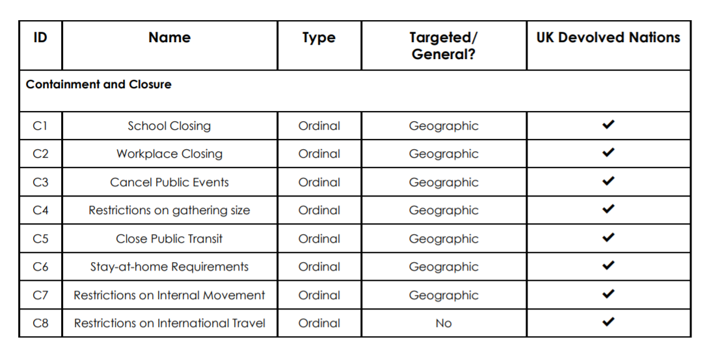

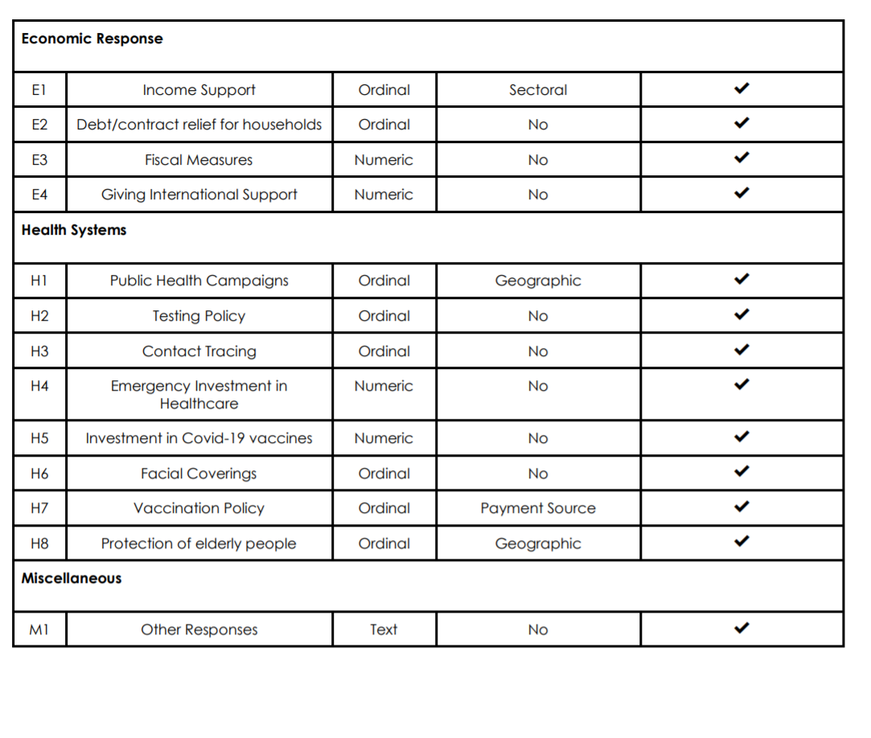

**France**

COVID-19 has seriously affected France. The first confirmed case of covid-19 was reported on 24 January 2020. The level of infection is still very high, with repeated surges, and a third wave of infection is currently occurring. Since mid March 2020, the government has taken a series of containment measures, the first national blockade at that time to reduce the spread of covid-19. The French economy contracted by 8% in 2020. In 2021, the economy contracted by 0.1% in the first quarter compared with the previous quarter. Covid-19 vaccination began on December 28, 2020. As of June 2021, more than 33 million people had received at least one dose of vaccine.

Reopen the economy and take additional containment measures:

* France began to relax the first round of containment measures in mid May 2020, starting with the reopening of primary schools, shops and industries on the basis of different regions.
* By the end of June 2020, most of the major domestic restrictions related to the first blockade had been lifted (including travel restrictions).
* The resurgence of infection in August 2020 prompted the government to first implement a regional curfew, and finally implement (partially) a second blockade at the end of October 2020, keeping schools open. After the gradual lifting of the second blockade, the maintenance of curfews and partial restrictions, the third partial blockade was implemented in March 2021, first regional and then expanded nationwide. From May 2021, the economy will be reopened from the third blockade.

From：<https://www.imf.org/en/Topics/imf-and-covid19/Policy-Responses-to-COVID-19>

**Finance:**

* The authorities introduced four revised budget laws between March and November 2020, increasing the total amount of Finance used to respond to the crisis to about 180 billion euros (about 8% of GDP, including liquidity measures).
* This adds € 32.75 billion (close to 15% of GDP) to the public guarantee package, including € 315 billion for bank loans and credit reinsurance programs.
* The 2021 budget included additional funding for the emergency plan, which was subsequently expanded in ongoing containment measures (about 3% of GDP, including those in the amendment currently under discussion).
* The 2021 budget also includes key elements of the fiscal plan ("relief plan") announced in September 2020 to support France's economic recovery. The recovery plan includes measures totalling about 100 billion euros over two years, focusing on the ecological transformation of the economy, improving the competitiveness of French enterprises and supporting social and territorial cohesion. About $40 billion of the plan is expected to be provided by the EU recovery fund.

From：<https://www.imf.org/en/Topics/imf-and-covid19/Policy-Responses-to-COVID-19>

**Germany**

Germany registered the first confirmed case of covid-19 on January 27, 2020. The government has taken a series of measures to curb the spread of the virus, including closing borders, closing schools and non essential businesses, maintaining social distance, enforcing the wearing of masks and banning public gatherings. Following the steady decline since early April, the infection rate rose again. Since late July, the daily new cases have gradually increased, and now they have exceeded the previous peak. Although the mortality rate is rising, it is still very low compared with peer countries.

**Reopening the economy:**

* On April 20, small shops reopened according to the requirements of social distance.
* On May 4, some grades of the school were gradually reopened, as were cultural and leisure places.
* On 6 may, the government announced a further relaxation of containment measures for all shops, restaurants and sports facilities, with a specific timetable to be determined at the state level. The reopening is affected by the "emergency brake", that is, more than 50 new infections per 100.000 residents in seven days, which will require the state government to reverse the reopening and re implement containment measures.
* From May 16, border controls on neighbouring countries will be phased out.
* Since May 18, some states have cancelled the isolation requirements for passengers from EU countries.
* On May 26, the federal and state governments agreed to relax restrictions on public gatherings of up to 10 people or two independent families, subject to the minimum distance in public places and the requirement to wear masks. The travel warning for all EU countries, Schengen countries, the UK and Northern Ireland was lifted on June 15, although some "high-risk" destinations have been placed under the travel warning as the infection recovers. On June 16, the government launched the corona warning application, which allows users to track potential contact with covid infected people on a voluntary and anonymous basis.
* On July 1, the entry restrictions on passengers from 11 non EU countries were lifted (3 of which were conditional on reciprocity). The travel warning for all EU countries, Schengen countries, the UK and Northern Ireland was lifted on June 15, although some "high-risk" destinations have been placed under the travel warning as the infection recovers. On June 16, the government launched the corona warning application, which allows users to track potential contact with covid infected people on a voluntary and anonymous basis.
* On July 1, the entry restrictions on passengers from 11 non EU countries were lifted (3 of which were conditional on reciprocity). The travel warning for all EU countries, Schengen countries, the UK and Northern Ireland was lifted on June 15, although some "high-risk" destinations have been placed under the travel warning as the infection recovers. On June 16, the government launched the corona warning application, which allows users to track potential contact with covid infected people on a voluntary and anonymous basis.
* On July 1, the entry restrictions on passengers from 11 non EU countries were lifted (3 of which were conditional on reciprocity).

From：<https://www.imf.org/en/Topics/imf-and-covid19/Policy-Responses-to-COVID-19>